Software Engineering Project Proposal
Report one

Team leader：Lewis
Member：Lewis, Wade, Rick, Troy

URL: https://github.com/Lewis1124/Online-recruitment-system
https://github.com/Rrick001/Online-recruitment-system/blob/master/Rick.doc
https://github.com/WadeDuyongheng/Online-Recruitment-System/find/master?q=
https://github.com/Troy001/Online-Recruitment-System/blob/master/Troy.doc

Table of Contents
Work breakdown form——Report one part one 2
Work breakdown form——Report one part two 3
Customer Problem Statement 5
a. Problem Statement 5
1. b. Glossary of Terms 8
2 System Requirements 9
.a Functional Requirements 9
2.b. Nonfunctional Requirements 10
2. C：User Interface Requirements 10
A Brief Introduction to Job-hunting Companies 11
3. Functional Requirements Specification 12
i. Casual Description 13
Ii. Use Case Diagram: 14
4 User Interface Specification 40
a Preliminary Design 40
b User Effort Estimation 42
Project Management : 47

Work breakdown form——Report one part one

 |  | Lewis | Wade | Rick | Troy
Res | Project | 30% | 30%  50% | 20% | 20%
pon | management | 50% | 30%  50% |  | 20%
sibi | Customer Problem |  |  | 50%  75%  30% | 50%  25%  70%
lity | Statement |  |  | 50%  75%  30% | 50%  25%  70%
 | Glossary of Terms |  |  | 50%  75%  30% | 50%  25%  70%
lev | System | 60% | 40%
els | Requirements | 60% | 40%
 | Enumerated Functional Requirements | 100%
 | Enumerated Functional Requirements |  | 100%
 | User Interface | 70% | 30%
 | Domain Analysis |  | 20% | 10% | 50%
 | Plan of Work | 80% |  |  | 20%

Work breakdown form——Report one part two

 |  | classification
 |  |  | Lewis | Wade | Rick | Troy
Res  pon  sibi  lity  lev  els | Functional Requirements Specification | Stakeholders |  | 100%
Res  pon  sibi  lity  lev  els | Functional Requirements Specification | Actors and Goals | 30% | 70%
Res  pon  sibi  lity  lev  els | Functional Requirements Specification | Use Cases | UC-6  UC-7  UC-8  UC-9 | UC-3  UC-4  UC-5 | UC-1  UC-2 | UC-10  UC-11
Res  pon  sibi  lity  lev  els | Functional Requirements Specification | System Sequence Diagrams | 100%
Res  pon  sibi  lity  lev  els | User Interface Specification | Preliminary Design |  |  |  | 100%
Res  pon  sibi  lity  lev  els |  | User Effort Estimation |  |  | 100%
Res  pon  sibi  lity  lev  els | Project Management | Plan of Work | 50% | 50%
 | Project Management | References | 25% | 25% | 50%

Customer Problem Statement

a. Problem Statement
As a client who is looking for a job, I need to define my goal and direction first. I need to find a suitable job for my major. My major in university is information management, so I think about finding a job about information technology and information statistics. As a contemporary job seeker, because of the rapid development of the Internet, I prefer to apply for jobs through the Internet model.
But I also have my own concerns. The first point is that the online recruitment model has not been fully popularized. I am worried about the immaturity of the online recruitment model. The second point is that because the major of information management involves a wide range of work, I will worry that some good companies are not popularized, leading to the company I want to enter. The third point: Compared with the normal recruitment model, online recruitment fair. Don't miss some key details. Fourth point: Risk problem, online transactions do not face-to-face exchanges, so it may lead to difficult agreement between the two sides, but if it is offline recruitment, there will be no such problem. Fifth point: salary problem, online recruitment, salary is often fixed, not easy to change for some personal reasons, but offline recruitment, face-to-face form makes this problem solved very well.
However, excluding these concerns and concerns, I think online recruitment also has many advantages, such as: more convenient, faster, more extensive, help us to improve the efficiency of finding a job, find a good job, we not only save time, but also have more choices. We can apply for entry and online interviews to multiple companies at the same time, but if in the Offline, we not only need to allocate the limited time reasonably, but also have not so many choices of online recruitment.
As a job seeker, my most concern is the reliability of the online recruitment system, because of this concern, so I launched an inquiry to your company's human resources department, they told me that the company's human resources department employees can use this recruitment system to prepare questionnaires and publish questionnaires related to the required positions; job seekers can submit resumes and resumes through this system. Answer the questionnaire.Then, the employee systematically counts these resumes, and chooses the interviewees according to the resume and questionnaire scores of the job seekers. Employees issue questionnaires and positions in the system, and then job seekers submit resumes and answer questionnaires. After that, employees can easily choose the right interviewees by simply selecting employees with high scores and checking their resumes.
As the first job seeker to use the online recruitment system, I am concerned about the fairness of this system. As we all know, offline recruitment is often unfair and false. Therefore, if online recruitment system as a new thing in the new era, in order to replace the traditional recruitment model, the issue of fairness must be solved. As the founder of the online recruitment system, he told me that most of the managers responsible for browsing and reviewing the resumes of job seekers are company managers, mainly human resources managers and system managers, who are familiar with the recruitment business. Then the system is divided into client and management. Customer's main functions are to supply and demand jobs, resume entry, answering questions, resume submission, etc. The function of management terminal is to provide company managers with knowledge management, questionnaire management, post release, resume management and user management. Then the system interface design, system structure design, data design, module design, interface design and so on, because we do not know much about the details, the completion of the system may take a long time. Therefore, this process can ensure the fairness of online recruitment, each step will have a dedicated staff to strictly check his fairness, which is why the online recruitment system can replace the traditional recruitment model is an important reason.
Therefore, this process can ensure the fairness of online recruitment, each step will have a dedicated staff to strictly check his fairness, which is why the online recruitment system can replace the traditional recruitment model is an important reason. We believe that the online recruitment system will replace the traditional recruitment model.

b. Glossary of Terms



2
.

Identifier | Priority | Requirement
REQ1 | 3 | The system enables users to register and log in
REQ2 | 5 | The system enables user recruiters to post jobs on the system
REQ3 | 3 | The system enables the question bank manager to change the question bank and questionnaire independently.The system enables the question bank manager to change the question bank and questionnaire independently.
REQ4 | 4 | The system enables candidates to answer questions after selecting a position.
REQ5 | 2 | The system enables recruiters to see the resumes of different candidates on the system.
REQ6 | 5 | The system enables recruiters to interview in the system corresponding candidates
REQ7 | 4 | The system enables job seekers to fill in resumes
REQ8 | 1 | The system can manage the personnel on the system

2.

Identifier | Priority | Requirement
REQ1 | 3 | The system should search according to the number and name specific conditions during off-peak hours, and can get search results within 3 seconds.
REQ2 | 2 | The system can satisfy 50,000 user requests at the same time and provide browsing functions for 25,000 concurrent users.
REQ3 | 2 | The system supports 50,000 users and supports GB-level data.
REQ4 | 1 | The system provides data backup and recovery functions, enabling data to be recovered and restored in time when system data is lost or system data is corrupted due to system errors or other reasons.
REQ5 | 2 | The system should support IOS, Android, Windows operating system.
REQ6 | 1 | The system requires the system to run 24 hours a day, and the continuous operation failure time of the whole year cannot exceed 10 hours.
REQ7 | 2 | The system should be encrypted and not cracked
REQ8 | 3 | In 95% of the system failures, the system needs up to 20 seconds to restart.
REQ9 | 5 | 90% of the system's BUG modification time does not exceed 1 working day, and the other does not exceed 2 working days.

C：User Interface Requirements
Non-functional Requirements:
A Brief Introduction to Job-hunting Companies
Personnel distribution in job-seeking companies
Recruitment flow chart
Real-time progress in recruitment
Number of job seekers in the same position

Interpretation: Enter the Online Recruitment Platform

Interpretation: Asking for help in the recruitment process

Interpretation: Customer Service Consulting
目录

Project Management
After that, our team will complete the functional requirements specification, user interface specification, domain name analysis, Project size estimation based on use case points. These will be completed in the next four weeks.

Functional Requirements Specification
Stakeholders: Job seekers, recruiters and Administrator of Recruitment System.

B Actors and Goals:
Actor Actor’s goal Usecase name
Administrator Manage job seekers and recruiters' User management
information and all matters in the system.

Job seekers recruiters Users (recruiters and job seekers) enter User registration system
the registration page and fill in personal
information to obtain personal accounts.

Job seekers recruiters The user logs in to the system interface User login system
after completing the registration.

Recruiters Recruiters publish recruitment information Job posting
to the system interface.

Job seekers Job seekers check all the recruitment Job selection
information and choose their favorite job.

Job seekers Administrator Job seekers upload resumes to Resume input
administrators after choosing jobs.

Job seekers Administrator Administrators accept and manage Resume management
job seekers'resumes.

Job seekers recruiters An interview is arranged after the Interview management
recruiter is satisfied with the candidate's resume.

Administrator Administrators organize question Question bank
banks to facilitate the start of questionnaires. Management

Job seekers recruiters Questionnaire survey after users Questionnaire answer
use the system.

Administrator At the end of the questionnaire survey, Questionnaire
The administrator manages the results management
of the questionnaire and gets feedback
from the users.
C Use Cases:

Casual Description
UC-1 User Registration: Users need to register an account in order to log in to the system.
UC-2 user login: The user logs in to the system using the account to use the system.
UC-3 Question Bank Management: The management of the question bank mainly completes the increase and decrease of test questions, such as modification and query maintenance.
UC-4 Questionnaire Management: Questionnaire management is mainly to organize questionnaires.
UC-5 Job Post: Recruiters post jobs on the system to offer employer choices
UC-6 Job Selection: The job selection is to display all positions currently recruited and descriptions and requirements for each position.
UC-7 Questionnaire Answer: Candidates will answer questions after selecting a position, and the system will give a score.
UC-8 Resume Entry: Candidates pass their resumes to the system
UC-9 Resume Management: Recruiters browse the candidate's resume on the system
UC-10 Interview Management: For candidates who meet certain conditions, they can interview and record the results.
UC-11 User Management: System administrators can set permissions
Ii.:

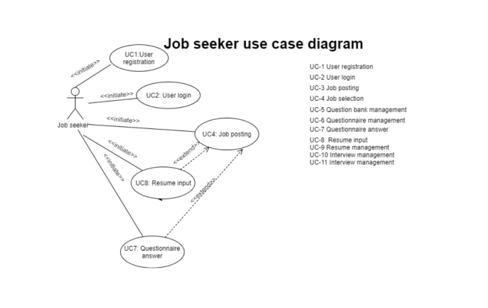
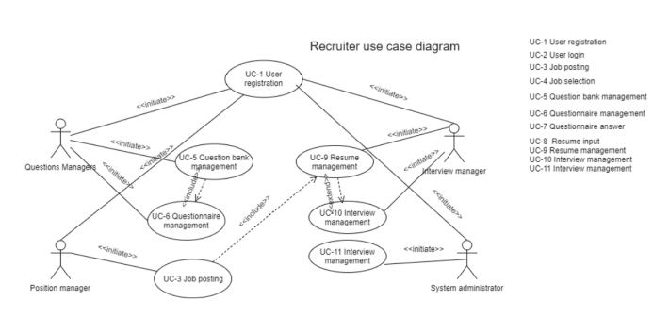
Iii Traceability Matrix：
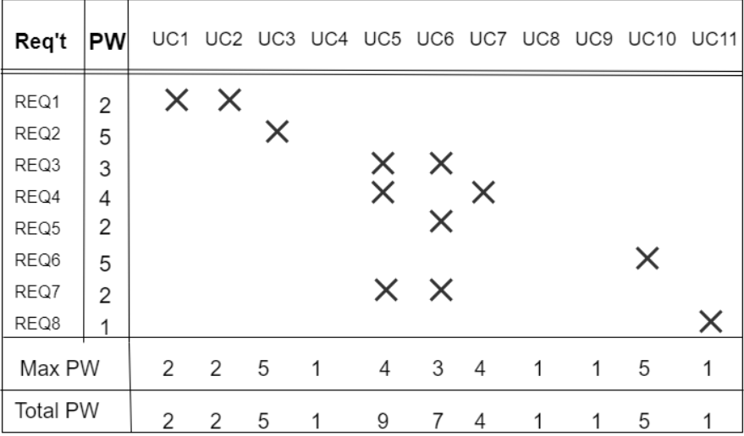

Iiii Fully-Dressed Description:
Use Case UC-1: |  |  | User registration system
Related Requirements: |  |  | REQ1and REQ6
Initiating Actor: |  |  | Recruiter, job seeker
Actor’s Goal: |  |  | Users sign up for an account
Participating Actors: |  |  | Job seekers, recruiters
Preconditions: |  |  | New users need to register first
Postconditions: |  |  | After registering, you can log in to the system.
Flow of Events for Main Success Scenario:
→ | 1. | The job seeker enters the registration page of the website
 | 2. | After filling in the personal information, you will get an account for your own use.

Use Case UC-2: |  | User login system
Related Requirements: |  | REQ1
Initiating Actor: |  | Job seeker, recruiter, administrator
Actor’s Goal: |  | The user enters the recruitment system using the registered account
Participating Actors: |  | Job seekers, recruiters, administrators
Preconditions: |  | The administrator needs to verify the legality of the user's registered account.
Postconditions: |  | Determine whether the user is allowed to enter the system.
Flow of Events for Main Success Scenario:
→ | 1. | The job seeker uses the registered account for verification
✶ | 2. | The administrator judges according to the legality of the account registered by the job seeker
 | 3. | The job seeker logs in to the system.

Use Case UC-3: |  | Job posting
Related Requirements: |  | REQ2
Initiating Actor: |  | Position manager
Actor’s Goal: |  | Managers post job information through the needs of the company, detailing the needs of the position, candidates can see the position through the network and apply.
Participating Actors: |  | Position manager
Preconditions: |  | The position manager has logged in to the system
Postconditions: |  | If the position is successfully posted, the position information in the database changes, and the candidate can see the recruitment information through the network.
Flow of Events for Main Success Scenario:
→ | 1. | Enter the job posting interface, first show the positions currently being recruited, you can add new jobs.
✶ | 2. | A detailed description of each position can be viewed in detail by clicking on each position.

Use Case UC-4: |  | Job selection
Related Requirements: |  | REQ8
Initiating Actor: |  | Job seeker
Actor’s Goal: |  | Job selection is to show all the positions currently being recruited and the description and requirements of each position being recruited.
Participating Actors: |  | Job seeker Recruiter
Preconditions: |  | Applicants have logged in to the system.
Postconditions: |  | After choosing the position to apply for, you can enter your resume.
Flow of Events for Main Success Scenario:
→ | 1. | Candidates log on to the company's recruitment website, showing the current job listing, the date of publication, the number of recruits, etc.
✶ | 2. | Click on any job to browse the details of the job, including job description, requirements for applicants, recruiters and other information.
 | 3. | If you are satisfied with the position, you can click on "Apply for the position" to enter the resume information page and start filling in the resume and answering the questionnaire.

Use Case UC-8: |  | Resume input
Related Requirements: |  | REQ7
Initiating Actor: |  | Job seeker
Actor’s Goal: |  | If the applicant is satisfied with a certain position, he or she will start to enter his or her resume. The resume starts with the basic information of the applicant, then he or she will enter the work experience, education experience, basic skills, family members, self-introduction and so on. Finally, he or she will begin to answer the questionnaire.
Participating Actors: |  | Job seeker Recruiter Administrators
Preconditions: |  | The applicant has selected the position to apply for.
Postconditions: |  | After entering the resume, you can answer the questionnaire.
Flow of Events for Main Success Scenario:
→ | 1. | Basic information input, including name, sex, age, height, document type, document number, marital status, working life, expected monthly salary, residence, telephone, E-mail, address, zip code, etc.
✶ | 2. | Work experience information input, including start and stop time, work unit, unit information input.

Use Case UC-9: |  | Resume management
Related Requirements: |  | REQ7
Initiating Actor: |  | Candidate, interviewer
Actor’s Goal: |  | The interviewer will select a person who has achieved a certain grade as the selected subject and notify the interview time.
Participating Actors: |  | Candidates, interviewers
Preconditions: |  | The interview manager has logged in to the system
Postconditions: |  | After the resume is completed, you can divide the candidates into several categories to prepare for the interview.
Flow of Events for Main Success Scenario:
→ | 1. | Enter the resume management interface, first display the current job list corresponding to the resume, provide query function
✶ | 2. | Click on the job list to enter all resume list interface of the corresponding position
 | 3. | There are three processing results for the resume, through the interview, retain the resume, refuse
 | 4. | Applicants will be notified by the interviewer through the interview.

Use Case UC-10: |  | Interview management
Related Requirements: |  | REQ6
Initiating Actor: |  | Interview managers
Actor’s Goal: |  | The system administrator records the interview results
Participat |  | System administrator, candidate
Preconditions: |  | The interview manager has logged into the system
Postconditions: |  | If the interview is completed, the results of the interview are recorded in the database
Flow of Events for Main Success Scenario:
→ | 1. | Enter the interview management interface, display the current job listing, provide query function
✶ | 2. | Click on a position to enter the list of interviewees for that position
 | 3. | Classify interviewees into those who are waiting for notification, those who are waiting for interview and those who have completed the interview: for those who have not informed the interview and are informed to conduct the interview, its status will become the interviewee
 | 4. | Click on each person on the list to see the candidate's profile
 | 5. | When the interview is completed, it is necessary to record the interview time, the interviewee and the interview result, etc. After the information is submitted, the status of the interviewee will become the interviewee

Use Case UC-5: |  |  | Question bank management
Related Requirements: |  |  | REQ3 REQ4，REQ7
Initiating Actor: |  |  | Test manager
Actor’s Goal: |  |  | There is a set of question bank in the online recruitment system. The management of the question bank is mainly to complete the increase of test questions and reduce the maintenance of functions such as modification and query.
Participating Actors: |  |  | Test manager
Preconditions: |  |  | The test manager has logged into the system
Postconditions: |  |  | If the question bank is successfully maintained, the questions in the database will change, and the questionnaire can be organized at this time.
Flow of Events for Main Success Scenario:
→ | 1. | Enter the question bank management interface, first display the existing problems in the question bank.
✶ | 2. | Click on each topic to view the specific content of the topic in detail, and also modify the topic.
→ | 3. | When adding a question, first select the title category, then the title name, the title content, and determine the answer.
✶ | 4. | Can delete selected topics

Use Case UC-7: |  |  | Questionnaire answer
Related Requirements: |  |  | REQ4
Initiating Actor: |  |  | Job seeker
Actor’s Goal: |  |  | Questionnaire answers require candidates to answer all the questions in the questionnaire. According to the selected answers, the system gives the score, which candidates can not see.
Participating Actors: |  |  | Job seeker Recruiter Administrators
Preconditions: |  |  | Screen This has been entered into resume.
Postconditions: |  |  | After answering the questionnaire, you can submit your resume with the results of the questionnaire.
Flow of Events for Main Success Scenario:
→ | 1. | The applicants are asked to answer the questionnaires of value orientation and work orientation..
✶ | 2. | There are choice questions in each set of questionnaires. Only after all the questionnaires have been answered, can the questionnaires be submitted.
→ | 3. | Finally, the resume information and the questionnaire were submitted to the server side.

Use Case UC-11: |  | User management
Related Requirements: |  | REQ8
Initiating Actor: |  | system administrator
Actor’s Goal: |  | To enable system administrators to more systematically manage job candidates as well as job information
Participating Actors: |  | system administrator, candidate
Preconditions: |  | The system administrator has logged into the system
Postconditions: |  | If the user information is maintained, the corresponding information of the user will be recorded in the database
Flow of Events for Main Success Scenario:
→ | 1. | Enter the user management interface to display the current system users and the permissions of each user.
✶ | 2. | Click on different users, the user's information and corresponding permissions can be displayed, and the permissions can be modified if necessary
 | 3. | You can add or remove users

Use Case UC-6: |  |  | Questionnaire management
Related Requirements: |  |  | REQ5,REQ6,REQ7
Initiating Actor: |  |  | Paper manager
Actor’s Goal: |  |  | Questionnaire management is mainly to organize questionnaires. The questions in the questionnaires all come from the question bank. Each questionnaire has different pertinence, and it is targeted at different recruitment needs.
Participating Actors: |  |  | Paper manager
Preconditions: |  |  | The test paper manager has logged in to the system
Postconditions: |  |  | If the questionnaire is successfully maintained, the database questionnaire will change accordingly, and the appropriate questionnaire can be selected when posting the position.
Flow of Events for Main Success Scenario:
→ | 1. | Enter the questionnaire management interface, first display the existing questionnaire.
✶ | 2. | Click on each questionnaire to view the topics of each questionnaire in detail.
→ | 3. | Some topics can be deleted, or the order of each topic can be rearranged, and the entire questionnaire can be previewed.
✶ | 4. | Provide a button to increase the questionnaire. When adding a questionnaire, select a question from the question bank.
 | 5. | Can delete selected questionnaires

D System Sequence Diagrams:
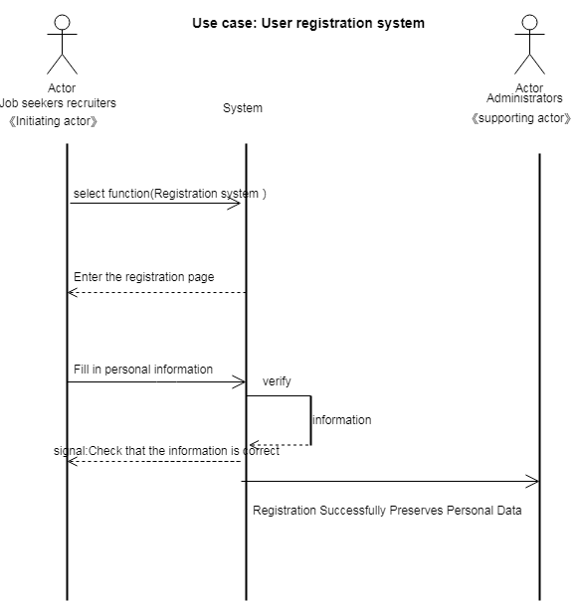
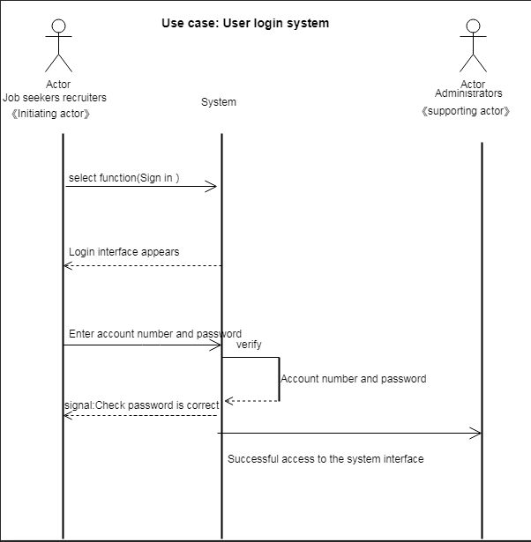
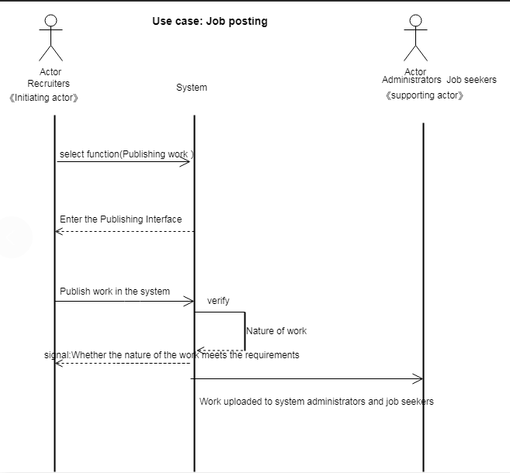

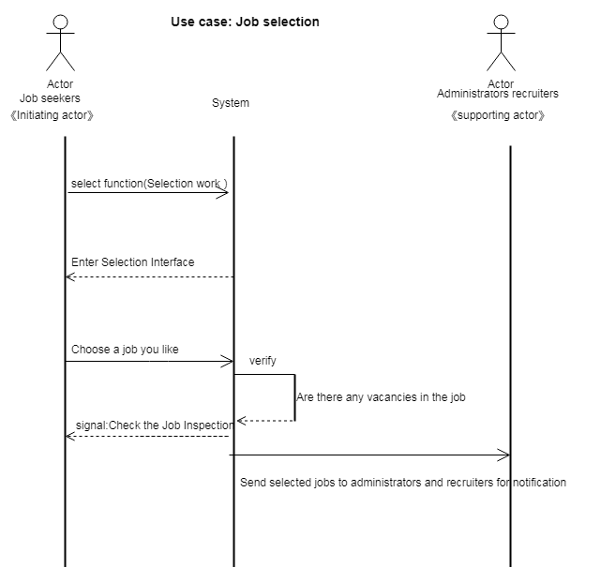

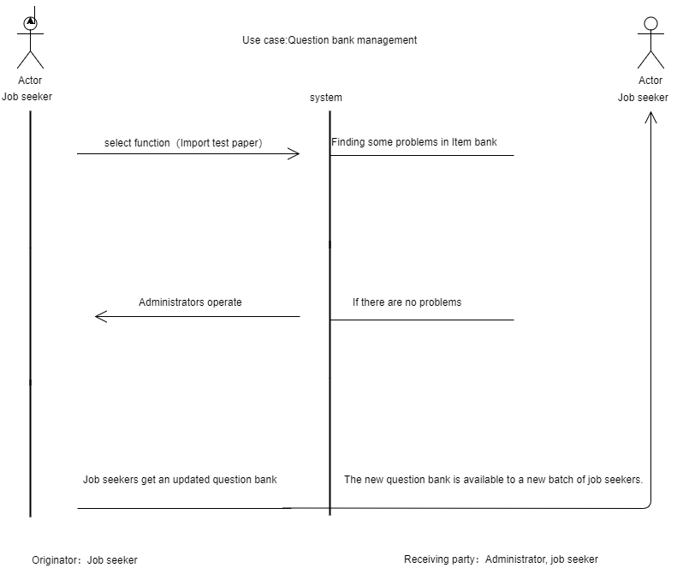

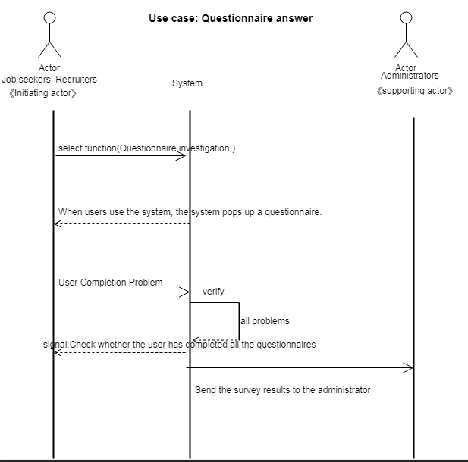
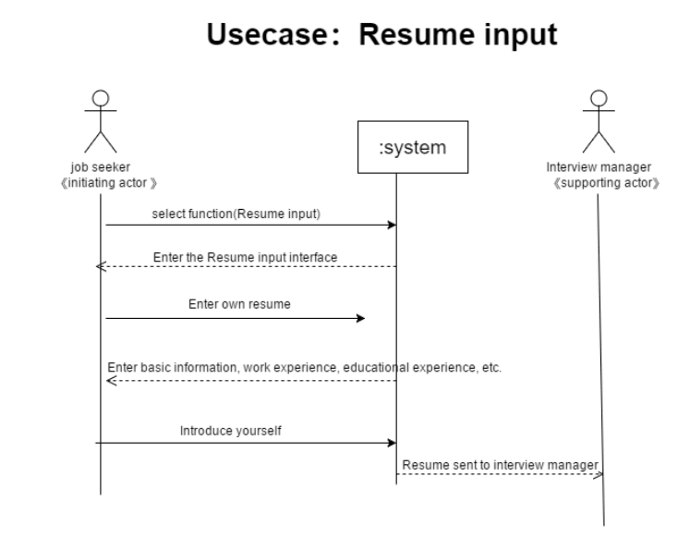
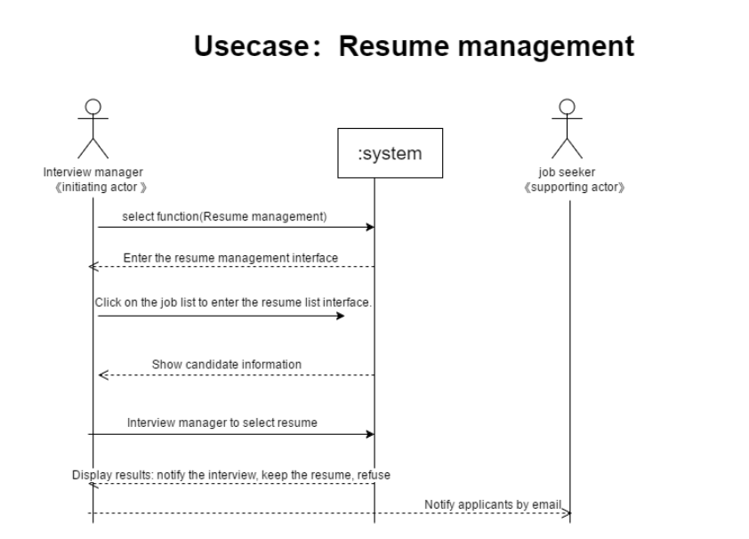
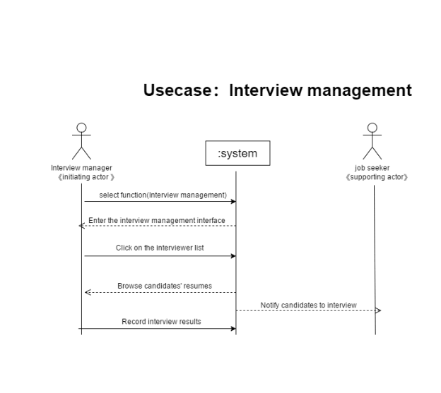
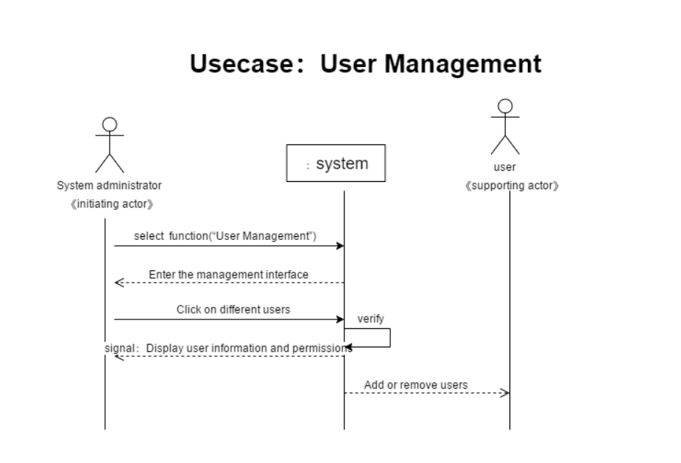

4 User Interface Specification

a Preliminary Design
A.
Enter the registration interface and successfully register the account of online recruitment platform
Assuming the APP has been opened, what you need to do is :(1). Fill in the specific information. (2) bind the mobile account to complete registration
1. Fill in the specific information: 13 mouse clicks in total, as shown below
a. Click on each field
b. Complete each item
c. To complete, click next
2. Bind mobile account to complete registration: 4 mouse clicks in total, as shown below
a. Click the register mobile phone number/E-mail input box to enter the mobile phone number/E-mail
b. Click get captcha request
c. Click the captcha input box to enter the captcha received by your phone/email
d. Click finish registration
Note: please make sure that every item of information is filled in truthfully and there are no typos, otherwise the system will not be able to recognize it.
B.
Enter the login interface and log in the online recruitment APP successfully
Assuming you haven't opened the APP yet, what you need to do is :(1). Open the APP. (2) fill in the account information and log in
1. Open the APP: 1 mouse double click in total
2. Fill in account information to log in: 3 mouse clicks in total, as shown below
a. Click the mobile phone number/E-mail input box and enter the mobile phone number/E-mail
b. Click the get captcha option to get the captcha
c. Click the login key to log in successfully
Note: please make sure it is your mobile phone number/email address, otherwise you will not be able to log in successfully
C.
Successfully registered for online recruitment
Assuming the APP has been opened, what you need to do is :(1). Open the recruitment and registration service. (2) confirm personal information (the registration information is confirmed again). (3) fill in personal expectation and complete the registration. (4) successful registration
1. Open the recruitment application service: 1 mouse click in total
2. Confirm personal information (the registration information is confirmed again) without mouse operation
3. Fill in the expectation of the person and complete the registration, with a total of 4 mouse clicks, as shown below
a. Click on each box (expected company, expected position, expected salary)
b. Click next
4. Please wait for the interview notification if your application is successful. No mouse operation is required
Note: personal information must be confirmed in person, do not make mistakes, otherwise it may lead to the failure of the resume submitted at your own risk
D.
Deal with the problems in the process of online recruitment
Suppose you have opened the APP and finished the registration. Now there is a problem. What you need to do is :(1). (1) online recruitment progress query. 2. Other questions). (3). If you select the recruitment progress query, just watch the progress query. (4). If you choose other questions, please submit your questions and click finish
1. Open the problem handling icon in the recruitment, and click it once in total
2. Select the type of question (online recruitment progress query or other questions) and click next, 2 times in total
3. If you select the recruitment progress query, you can watch the progress query without mouse operation
4. If you choose other questions, please submit your questions and click finish, one mouse click in total
Note: please submit the questions truthfully, the target company will have a special person to verify, please wait patiently

b User Effort Estimation

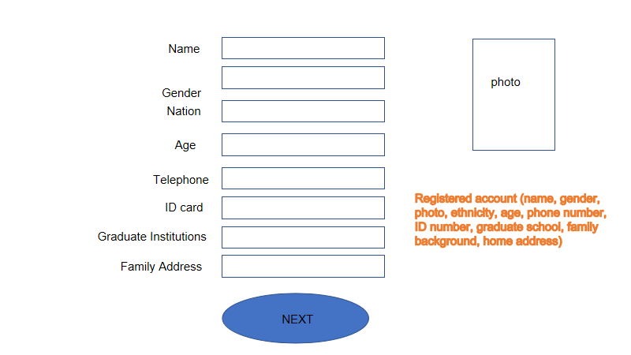
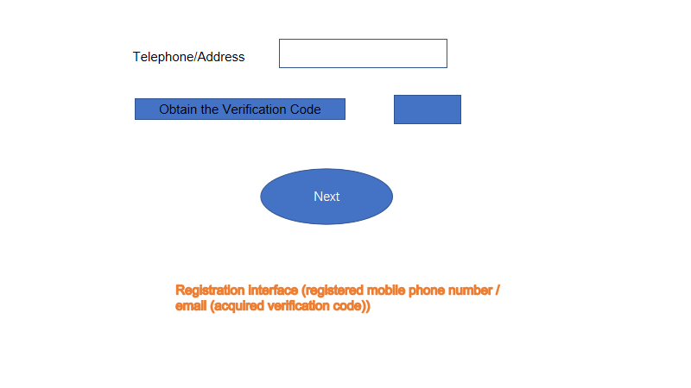
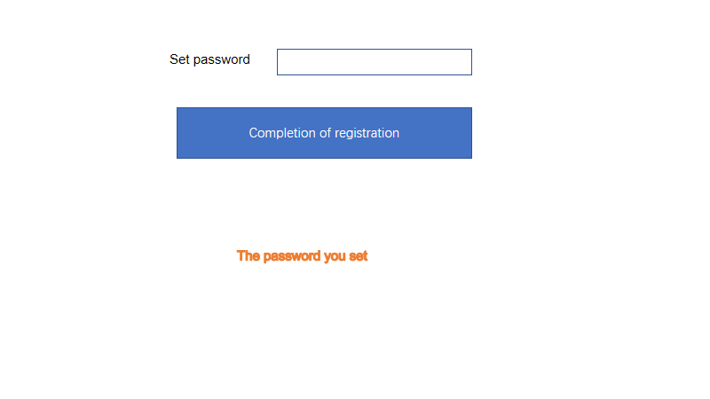
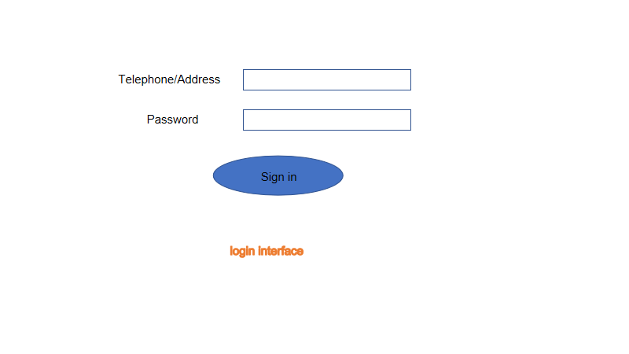
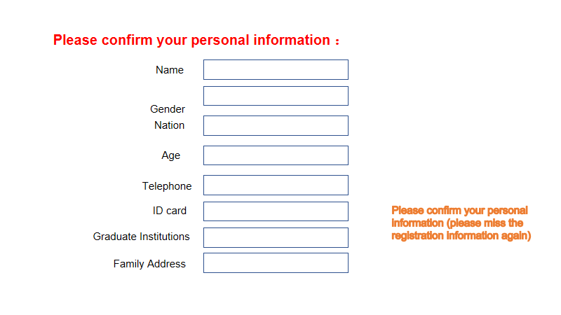

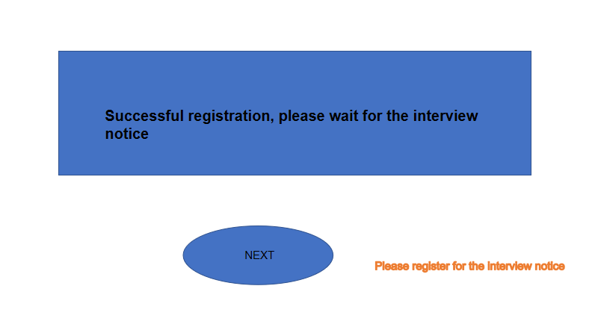
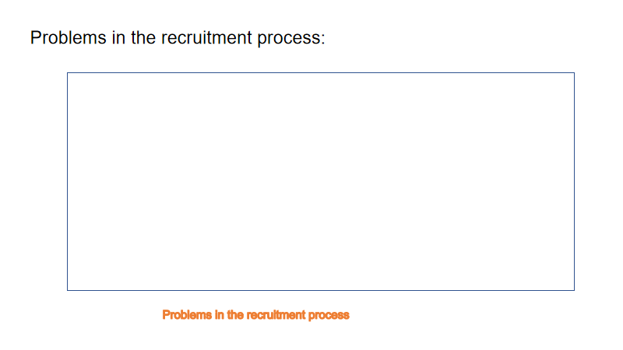
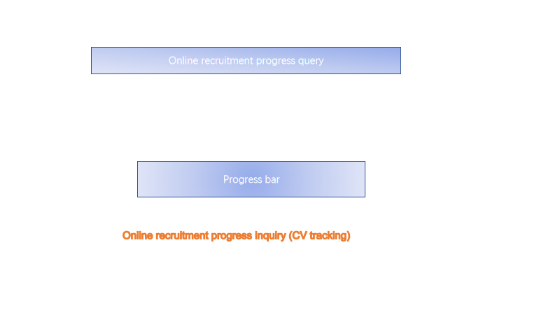
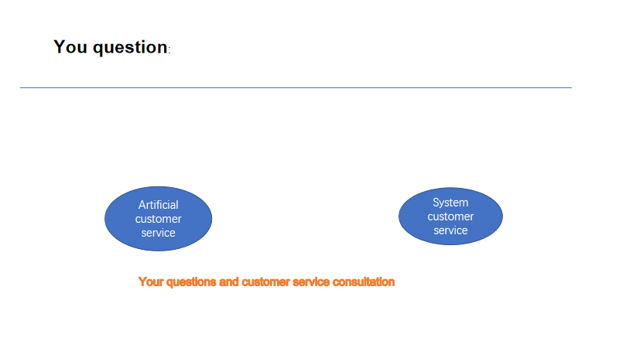
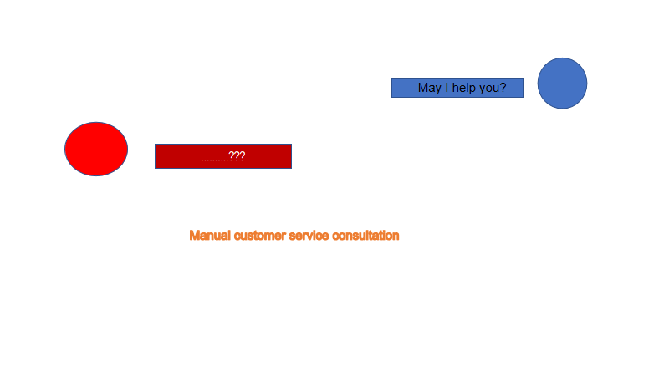
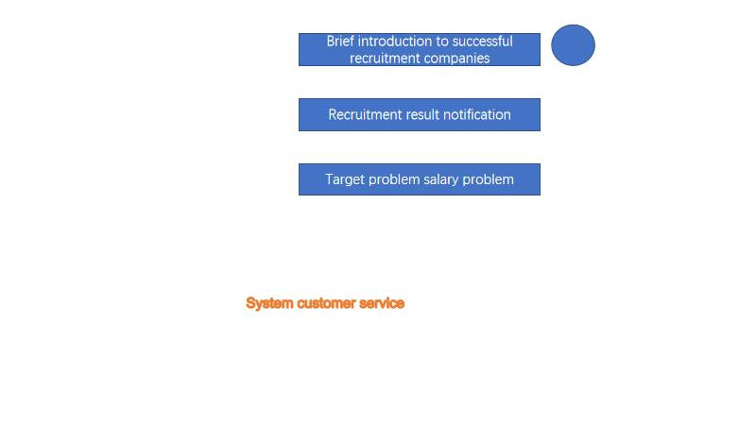

Project Management :
After submitting report#1, We have finished Functional
Requirements Specification and User Interface Specification. And the next step, we will work for Domain Analysis and Project size estimation based on use case points.
The main work analysis is as follows:
1. Requirement analysis: Through understanding customer business and discussing process with customers, the basic requirement model is built, and finally the requirement specification is formed.
2. Overall design: Through the analysis of demand information, the system's external conditions and internal business requirements are abstractly modeled, and finally a summary design description document is formed.
3. Detailed design: This part carries on the detailed design of the system on the basis of requirement and outline design (also includes part of code description).
4. Develop and program the code of the system.
5. Trial analysis and system integration: all functional modules are tested by analog data and other correlation tests, and all module functions are integrated. Works submitted + completed.

The overall process of project development is as follows:
Planning Phase - Requirement Analysis Phase - Software Development Phase - Testing Phase - Completion

